TGFU Volleyball: A Game Performance Assessment Instrument (GPAI) – Dr Tim Hopper, 11/23/2026 – PE452 Uvic.

Observer watch assigned player and for each point,
- Focus on an on-the-ball or an off-the-ball movement skill.
- Record “” for an appropriate response or “X” for an inappropriate response for each movement skill as the point is played.
- After 3 or 4 points give feedback to your player based on your observations.
- Return to game focusing on new movement skill or repeat movement skill if improvement needed.
Skill - Sending the ball efficiently into the court to the appropriate target area or striking the ball in the hitting zone and setting up for recovery.
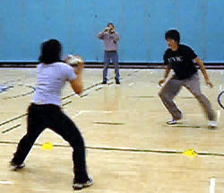 |  |  |  |  |  |  |  |  | 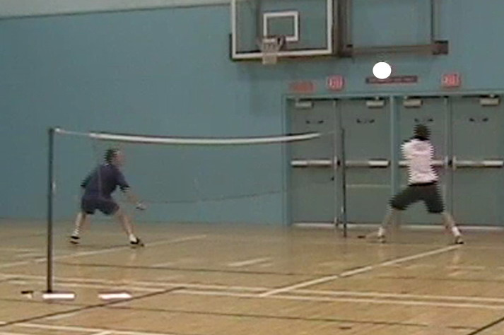
Base - Recover to a position to defend expected target area and set-up to attack opponent’s target area.
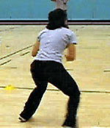 |  |  |  |  |  |  |  | 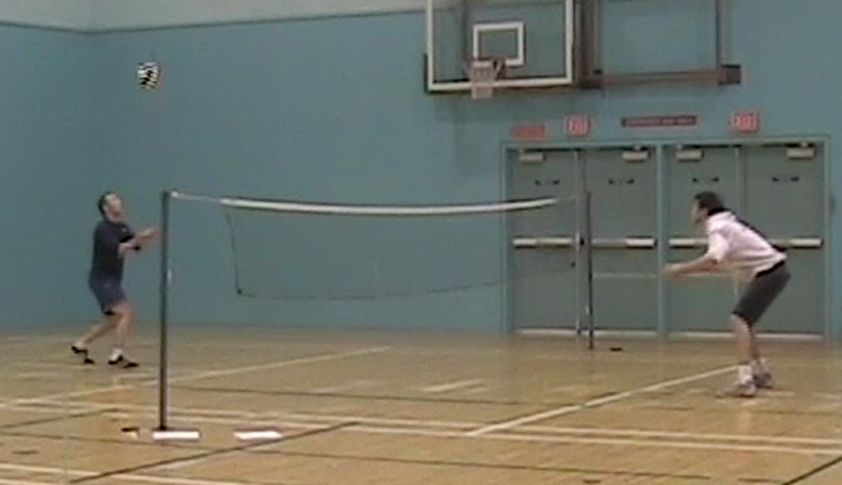
Decision - Read with anticipatory movement of 1) staying in base position, 2) moving-back to defend, or 3) moving-in to attack expected short ball.
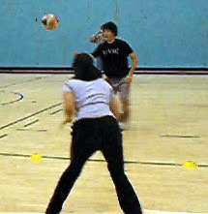 |  |  |  |  |  |  |  | 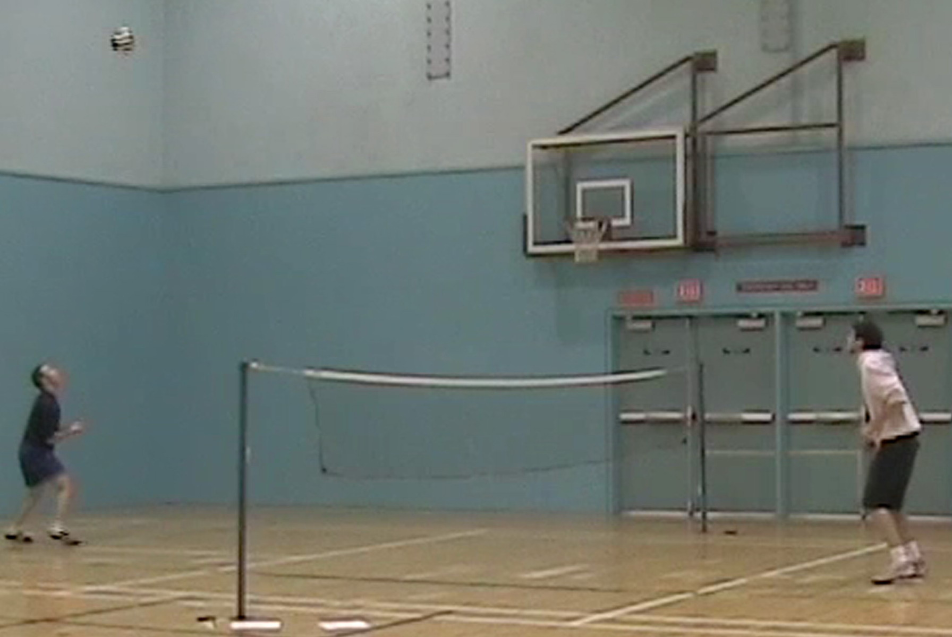
Cover - Respond with quick split-step preparation in opponent’s target area as opponent strikes the ball, then move to cover where ball sent.
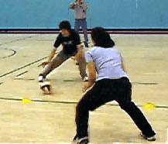 |  |  |  |  |  |  |  | 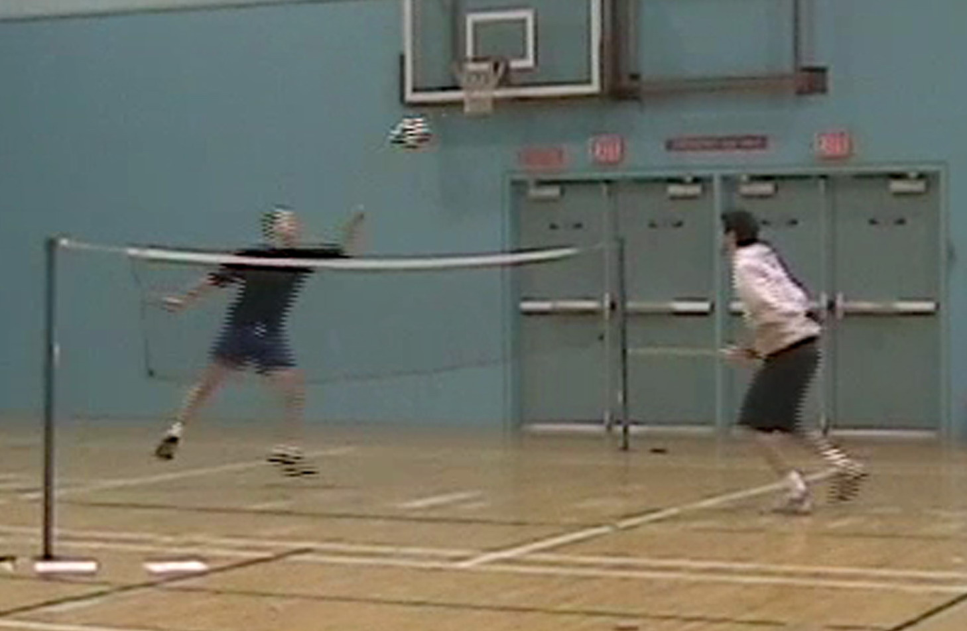
Adjust - React to ball with small push-off movements to set-up to execute shot in the hitting zone.
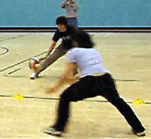 |  |  |  |  |  |  |  | 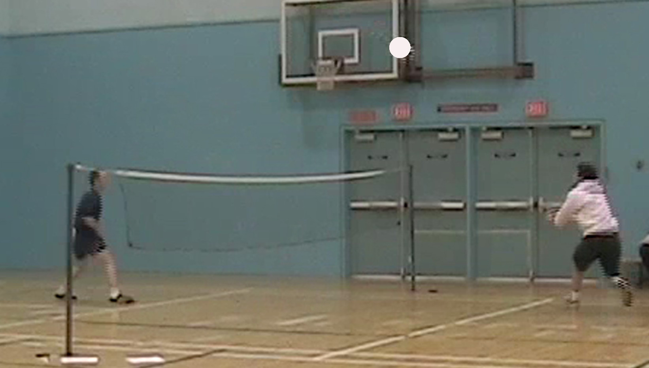

TGFU Volleyball: A Game Performance Assessment Instrument (GPAI) – Dr Tim Hopper, 11/23/2026 – PE452 Uvic.

Observer watch assigned player and for each point,
- Focus on an on-the-ball or an off-the-ball movement skill.
- Record “” for an appropriate response or “X” for an inappropriate response for each movement skill as the point is played.
- After 3 or 4 points give feedback to your player based on your observations.
- Return to game focusing on new movement skill or repeat movement skill if improvement needed.
Skill - Sending the ball efficiently into the court to the appropriate target area or striking the ball in the hitting zone and setting up for recovery.
 | ✓ ✓  ✓ |  | ✓ ✓  ✓ X |  | X ✓ ✓  ✓ |  | ✓ ✓  ✓
Base - Recover to a position to defend expected target area and set-up to attack opponent’s target area.
X ✓
✓ ✓
Too close to back-line
Decision - Read with anticipatory movement of 1) staying in base position, 2) moving-back to defend, or 3) moving-in to attack expected short ball.
✓ ✓ ✓
Good to move forward on short serve. Anticipate.
Cover - Respond with quick split-step preparation in opponent’s target area as opponent strikes the ball, then move to cover where ball sent.
 |  | ✓ X  X  Remember to jump as see opponent’s shot |  | ✓ ✓  ✓  Lot better. Looked quicker.
Adjust - React to ball with small push-off movements to set-up to execute shot in the hitting zone.
 |  |  |  | X X  ✓ X  Work on little steps, hitting ball to side |  | ✓ ✓ ✓  Nice footwork

